To: LCP Contacts
From: Colleen Riley, Director
Doug Boline, Assistant Director
Sandy Guidry, Assistant Director
Kerry Haag, Assistant Director
Vera Stroup-Rentier, Assistant Director
Tammy Mitchell, Assistant Director

Date: June 1, 2017

Re: Title I Parents Right to Know

No Child Left Behind (NCLB) includes several parental involvement requirements. One of those is that all districts within the State understand and comply with the requirement to notify parents in Title I schools when their children are assigned to or are being taught by a teacher who is not highly qualified in a core academic subject for four or more consecutive weeks. The Kansas State Department of Education (KSDE) must have evidence that all districts across the State complied with this provision for the school year 2016-2017.

Districts must provide KSDE a copy of an actual letter sent to parents in a Title I school for the 2016-2017 school year notifying them that their child was being taught by a teacher who was not highly qualified in a core academic subject for four or more consecutive weeks. This information must reach KSDE no later than August 1, 2017. Please complete the information below and indicate which of the following conditions apply to the district.

USD # _______________ District Name _____________________________

One or more of the Title I schools had a class or classes taught for four or more consecutive weeks by a teacher who did not meet the NCLB highly qualified teacher requirements. Attached is a copy of an actual letter sent to parents for the following
Title I school(s):

Name of school ______________________________________

Name of school ______________________________________

Name of school ______________________________________

All classes were taught by highly qualified teachers. There were no substitutes or teachers who were not highly qualified assigned to any one classroom for four or more consecutive weeks.

Please complete and submit via fax, mail or email by August 1, 2017to:
Nicole Clark
Early Childhood, Special Education & Title Services
Kansas State Department of Education
Landon State Office Building
900 SW Jackson, Suite 620
Topeka, KS 66612
Fax: (785) 291-3791
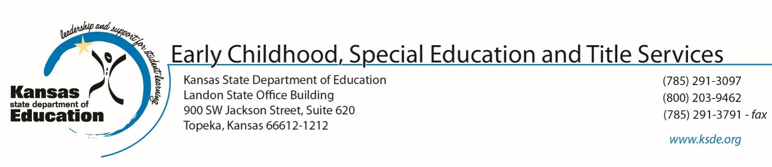
Email: nclark@ksde.org

